**Lab 4.2**

*What happens when you input 60 as the average?*

The program ends without any further intput/output. The mistake here is that the program is designed to have an output for an average either below or above 60, but not equal to it.

*Modify the first if statement so that the program will also print "You Pass" if the average equals 60. Take a screen shot of the output.*

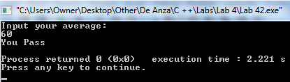

*Modify the revised program earlier to allow the following categories: Invalid data (data above 100), 'A' category (90-100), 'B' category (80-89), "You Pass" category (60-79), "You Fail" category (0-59). What will happen to your program if you enter a negative value such as -12?*

Nothing, it just ends without any further output (because I left my last else statement in blank. There was no indication on this lab to fill it in with a particular output).

